**SHELL COMMANDS**

***FILE ARGUMENTS***

**#!/bin/bash**

**echo “File Name : $0 ”**

**echo “File Argument : $1”**

**echo “Second Argument : $2”**

**echo “Argument Values : $@”**

**echo “Argument Values : $*”**

**echo “Total number of arguments : $#”**

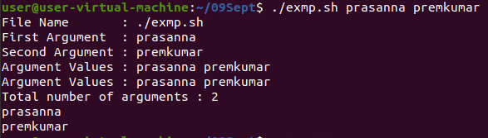

***GETTING INFORMATION FROM USER :***

**#!/bin/bash**

**echo “Enter the Employee No. : ”**

**read empno**

**echo “Enter the Employee Name : ”**

**read empname**

**echo “Enter the Employee City : ”**

**read empcity**

**echo -e “\n”**

**echo -e “Employee No. : $empno , \nEmployee Name : $empname and \nCity : $empcity”**

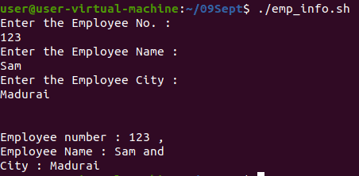

***PROGRAM TO SLEEP :***

**#!/bin/bash**

**echo “Process Started”**

**echo “Process is going to sleep for 5 sec”**

**sleep 5s**

**echo “Process wake up”**

**echo “task completed”**

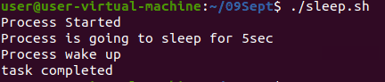

**TO FIND EXPONENTIAL :**

**#!/bin/bash**

**echo -n “Enter the BASE value : ”**

**read x**

**echo -n “Enter the POWER value : ”**

**read y**

**echo “The result is : $((x**y))”**

**#To increment the x value with 10**

**echo $((x+=10))**

**#To add the new x value with y**

**let “z=((x+y))”**

**echo $z**

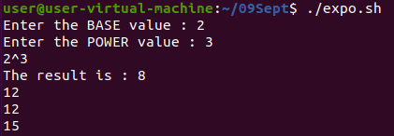

***TO FIND FACTORIAL :***

**#!/bin/bash**

**#Calculate the fact of user input**

**echo “Enter the number : ”**

**read n**

**fact=1**

**while [ $n -gt 1 ]**

**do**

**fact=$((fact * n))**

**n=$((n-1))**

**done**

**echo $fact**

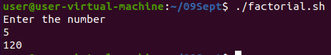

***MULTIPLICATION :***

**#!/bin/bash**

**echo “Enter the number : ”**

**read n**

**for i in {1..10..1}**

**do**

**echo “$i x $n = $((i*n))”**

**done**

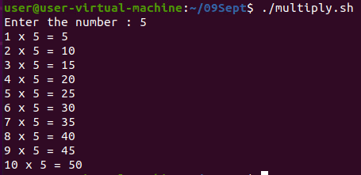

***EVEN OR ODD***

**#!/bin/bash**

**echo -n “Enter a number : ”**

**read n**

**if [ `expr $n % 2` == 0 ]**

**then**

**echo “$n is EVEN”**

**else**

**echo “$n is ODD”**

**fi**

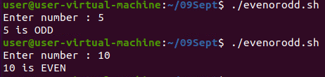

***GREATEST BETWEEN THREE NUMBERS :***

**#!/bin/bash**

**read -p “Enter n1 : ” n1**

**read -p “Enter n2 : ” n2**

**read -p “Enter n3 : ” n3**

**if [ $n1 -gt $n2 -a $n1 -gt $n3 ]**

**then**

**echo “$1 is the largest.”**

**elif [ $n2 -gt -n3 ]**

**then**

**echo “$n2 is the largest.”**

**else [ $n3 -gt $n2 ]**

**echo “$n3 is the largest. ”**

**fi**

**echo -e “Hi \nHello”**

